# Functional Description: System Interconnect

This section describes key system interconnect, NoC architecture concepts and features. Below figure illustrates the basic building blocks of the CFG System Interconnect architecture.



Figure 1. Bridge and Router Functions in the NoC

A bridge can connect a master of slave block to the NoC and perform the required operations to support the master and slave communication as per the protocol standards. A router can have four directional links, referred to as *north* (N), *south* (S), *east* (E), and *west* (W). It also can have up to four additional links to connect to up to four *host* (H, I, J, K). All eight links are identical and can be attached to bridges or to other routers.

## NoC Topology

The CFG NoC is a heterogeneous mesh-based interconnect that uses router elements organized in a heterogeneous 2D-mesh topology interconnected using point-to-point links. Below figure illustrates a full 2D-mesh interconnect, with a router at each mesh cross point.



Figure 2. A 4x4 Homogeneous Grid or Mesh Interconnect

The grid has a specific number of routers on the X and Y axes. The number is determined by the size of the network, with 4x4 being the number used in the figure. A router is identified on the grid using its XY coordinate. Each router has four directional ports (N, S, E, and W). The router can transmit and receive messages on each port over the interconnect wires, forming a point-to-point link between the router and the one adjacent to the port. Each router has four additional ports (H, I, J, K) that act as standard host-port connections through which the router connects to the host port of a host block. Host blocks receive and/or transmit messages from/to the network through the host ports. Host blocks and host ports connected to router injection ports are also shown in the figure. The directional ports, if not connected to an adjacent router, can be connected to a host port.

Heterogeneous mesh interconnects can also be designed using NocStudio. An example of such a design is shown in the figure. In this example, the hosts are heterogeneous in size and shape and are interconnected using a customized mesh topology. The customized mesh can be viewed as a sparsely-populated full mesh created by selectively removing one or more routers and/or one or more links from a full mesh. Using the host block locations (XY coordinates), sizes, and shapes, NocStudio automatically instantiates the routers and links to provide the needed connectivity.



Figure 3 A 4x4 heterogeneous grid or mesh interconnect

In a heterogeneous mesh, a host block can connect to one or more ports of one or more adjacent routers to transmit and receive messages. A host can only connect to multiple ports if it spans multiple grid cells. In that case, it can connect to the available router ports in the cells it spans. Referring to the above figure, Host13 is 3x2 (X by Y) in size, spanning six grid cells. The figure shows it connected to 11 ports on 5 routers, as follows:

* The H & K and one directional port (east) on the left router.
* The H on the top-left router
* The H & I port and one directional port(south) on the top middle router
* The I port of the top right router
* The I & J port and one directional port(west) on the right router

Notice that the six grid cells have two cross points inside the 3x2 host. Because links cannot go over a host, routers that might exist at the cross points cannot connect to other routers. Therefore, no routers are instantiated at the cross points. Because the cross-point routers are missing, the directional ports of adjacent routers are available for host-port connection. Each host port or bridge within the NoC has a unique identifier (ID) called the *bridge ID* that is used for routing messages.

### Multiple Physical and Virtual Networks

The NoC can contain up to eight (in 7-series version of the IP) physical mesh networks, or layers, for increased bandwidth and traffic isolation. Each physical layer operates in parallel, independent of the others. Up to four virtual networks can exist on each physical network, wherein different messages can be transmitted over different virtual networks. To implement virtual networks, every physical link in the physical mesh network has up to four virtual channels (VC). Virtual channels provide logical links over the physical channels connecting two routers ports. Each VC has an independently-allocated and flow-controlled flit buffer in the router nodes. In any given clock cycle, only one VC can transmit data on its physical channel.

The virtual network carrying a message is determined by NocStudio during the traffic mapping time (invoked with the map/map_opt commands) based on the priority and QoS requirements of traffic flows, and on the deadlock-avoidance requirements. Thereafter, all bridges are programmed so that messages are injected on the correct virtual and physical networks based on their QoS and destination information.

### Routing Choices in a Heterogeneous Topology

In a mesh NoC, shortest-path dimension-ordered routing is commonly used. In this routing, packets are routed along routers in one mesh dimension until they reach a router whose first-dimension coordinate matches the coordinate of the destination router. Then, the packet is turned in the second dimension toward the destination and continues until it reaches that destination. For example, in a 2D mesh, packets can first travel along the X dimension, and then along the Y dimension, creating an XY route. Routing can also be done via an YX route, i.e., travelling the Y dimension first. It is also possible for packets to take a staircase route with more than one turn. A staircase route has the same number of hops as an XY or YX route but requires more elaborate route information to be carried with the packets.

NoC allows routes to have up to sixteen turns; it is expected that, in most topologies, four turns will be sufficient to provide the needed connectivity and hence is the default in NocStudio. User can change this default to up to sixteen turns based on which, route information is encoded. NocStudio determines routes between sources and destinations and stores them in the transmitter bridges. By default, NocStudio gives preference to XY route, then to YX route; if neither of these routes is available NocStudio will use the shortest route available while honoring the set number of turns. Default routes may be modified with “set_route” command.

## Routers

Below figure shows the schematic symbol of a router component in the NocStudio RTL library. The CFG NoC uses 8-port routers. Four directional ports connect to the four adjacent neighboring routers and 4 additional ports connects to host ports using protocol specific bridges. Each router port may be bidirectional and uses flits to exchange message packets over the NoC. To generate RTL, NocStudio instantiates routers and link components based on the topological structure of the architected NoC. Routers employ several micro-architectural optimizations to minimize the effects of HOL blocking and provide high switching throughput. Internal paths, buffering, routing logic, QoS logic, arbitration and channel allocation logic, etc. are tuned and optimized for high-frequency operation and low latency. Support for various NocStudio features is closely integrated into the router. The Router component is also highly configurable to allow NocStudio to optimize each router in the network for best area, power and performance. Each router utilizes one clock cycle for internal processing logic. External link traversal can be optionally allocated an additional cycle or combined with the internal processing cycle based on operating frequency and latency requirements. Optional pipelining can also be deployed on longer links. A user interacts with NocStudio to individually optimize various sections of the generated NoC for physical design requirements.

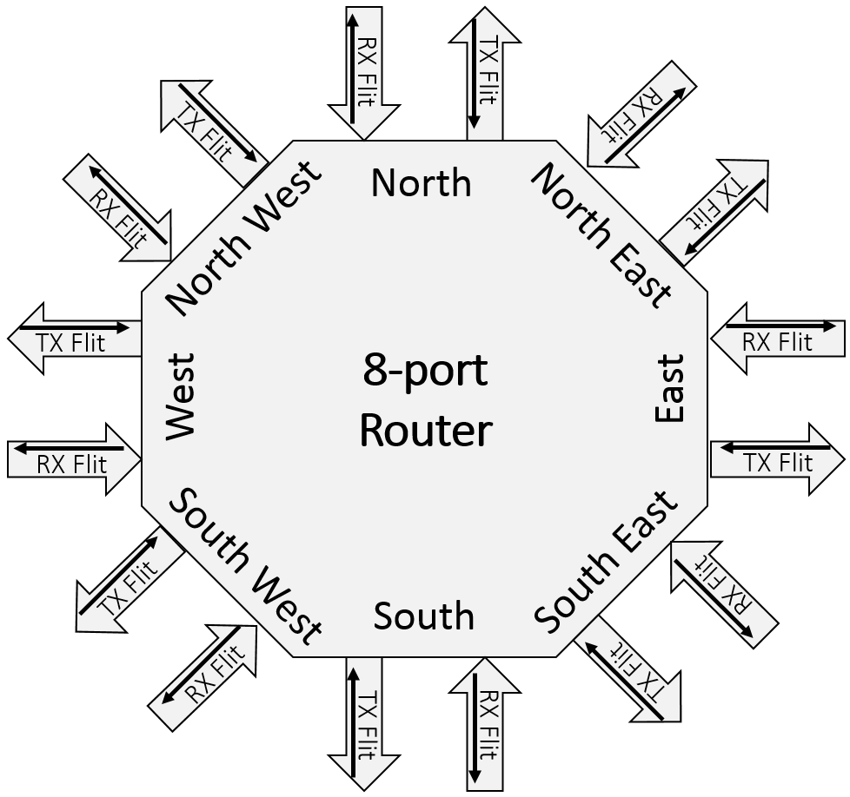

Figure 4. Schematic Symbol of a NocStudio RTL-Library Router Component

## Information Transport in the NoC

A bridge maps transaction messages issued from host port interfaces to NoC layers and VCs. The bridge also does the route computation, enforces QoS (fixed priority and weights), and packetizes data for transport over the NoC. Packetized data is sent by routers to the receiving bridge, which unpacks the data and translates it back to the host protocol. A request and response paths are shown in the figure.



Figure 5. Information Transport in the NoC

### Packetization

To transmit data between host ports and router injection/ejection ports, host transmit-data signals must be packetized and converted into a NoC-specific packet format. The bridge component converts the host output signals into NoC packets for transmission, and it converts packets received from the NoC routers back to the host input signals for delivery. With bridges between the host port and the router injection/ejection ports, a variety of hosts can be supported and connected using the same NoC.

All communication between router ports in the NoC is done using messages in the form of standard packets. NocStudio determines the route between source-host and destination-host port pairs based on several factors, such as the load on various links along the paths, message QoS, topology, etc. Every packet injected into the NoC by a bridge carries information about its destination host port and the route it should take. As a packet travels within the NoC, the routers use this information to send the packet to the next router until it reaches the destination router. The destination router delivers the packet to the bridge connected to the destination-host port.

Packets are composed of one or more flits. A single flit is transmitted or received at once (in one cycle) between various routers ports. The first packet flit is marked as start-of-packet (SOP) and the last flit is marked as end-of-packet (EOP).

### Arbitration

When an SOP is received at a router port, it participates in arbitration to allocate the output VC (this corresponds to the buffer allocated for the VC in the next downstream router). When the SOP wins arbitration, the output VC is allocated to the packet, and all subsequent packet flits use the same VC. The VC cannot be used by another packet until the EOP flit arrives, freeing the VC for use by another packet. When an output VC is allocated to a packet at an input VC, it must arbitrate for the output port. This is because multiple VCs can exist on the output port allocated to multiple packets at the input. This second arbitration occurs for every router output port. All packets at router input ports that have a VC allocated on the output port participate. The winning packet sends its flit in the same cycle. Thus, multiple VCs at a port can be interleaved. However, multiple packets are never interleaved within a single VC.

### NoC Channel Width and Heterogeneity

Flits are carried in NoC router channels, which are restricted to certain widths. Each flit carries overhead, and the number of flit payload bits varies with the flit size. Unless a flit is an EOP flit, the number of payload bits is restricted to a power-of-two multiple of cell_size. That value is fixed in NocStudio for the entire NoC project (the NoC project cell_size can be modified with the mesh_propcommand). EOP flits can contain any integer multiple of the cell_size payload bits. The value of cell_size must be selected based on the host-port signal properties to maximize the packing efficiency of the bridges. The figure illustrates a packet that is organized as two large flits or four small flits.



Figure 6. NoC Packet Organized in Two Different Flit Sizes

As packets traverse NoC channels of different widths, multiple flits can be combined into a flit with a larger payload, or a large flit can be sub-divided into multiple flits with smaller payloads. When flits are combined or divided, overhead bits are unchanged except for bits that identify a flit as EOP or SOP. For example, when flits in a two-flit packet (first flit is SOP and second is EOP) are combined, the resulting flit is marked as both SOP and EOP. Because a non-EOP flit is restricted to a power-of-two multiple of cell_size, only a power-of-two multiple of flits can be combined to form a large flit (unless an EOP is present). Similarly, a large non-EOP flit can only be sub-divided into a power-of-two number of small flits.

The NoC channel and buffer widths are sized to the message overhead bits and a power-of-two multiple of the cell_size. Flits adapt to the channel widths as they travel from one channel to another—either the flit payload is sub-divided into multiple flits, or multiple flit payloads are merged into a larger flit. When a bridge injects flits at the router injection port, the bridge must adjust the transmitted flit payload size to match the injection-port channel width. When flits are ejected from a router port to the bridge, the flit size is adjusted to match the router ejection-channel width. To achieve high clock rates, the NoC restricts the global flit-size conversion ratio between 1:16. Locally, within a bridge the conversion ratio is 1:16, and within a router it is 1:4. During traffic mapping and channel sizing, NocStudio ensures that channels are sized to meet this restriction.

Even if the NoC channels are sized at power-of-two multiples of cell_size, non-power-of-two flits can be combined if an EOP flits is in the set of flits being combined. The resulting EOP flit can contain a non-power-of-two multiple of flits. When an EOP flit moves from a wider channel to narrower channel it gets divided into the correct number of smaller flits. Figure illustrates merging and dividing flits under various channel-width scenarios.



Figure 7. Merging and Dividing Flits with Various Channel Widths



Figure 8. Combinations of Flit Merging and Division at Router Ports

### Determining NoC Channel Widths

NocStudio sizes NoC channels based on host-port data widths, the number of packet flits that traverse a channel, and the channel bandwidth requirement from all traffic flows sharing the channel.

The widths of router port channels connected to bridge interfaces are determined using bridge interface data. The number of bits an interface transmits or receives per cycle is rounded to an integer multiple of cell_size, and the channel is sized at this value. Single-beat messages (transmitted over the interface in a single cycle) are translated into a single flit packet. Multi-beat messages are translated into a multi-flit packets. Channels carrying multi-flit packets are rounded up to the nearest power-of-two multiple of cell_size. This is because two or four packet flits can be merged into a larger flit, or a large flit can be divided into multiple flits. Thus, all router port channels carrying single-flit packets are integer multiples of cell_size wide, and router port channels carrying multi-flit packets are power-of-two multiples of cell_size wide.

A similar convention is used for router directional channels, with the exception that a variety of messages can traverse the channels between various interfaces. Thus, all transaction messages and the corresponding packets are examined. If all packets are single-flit packets, the width can be an integer multiple of cell_size. If any packet is multi-beat, the width is rounded to nearest power-of-two multiple of cell_size. The channel widths can be increased during NoC optimizations using the bandwidth requirements and flit size distributions.

For more information on channel optimizations, refer to the tune_links and analyze_links commands. Refer to the VC Mapper section for a step-by-step detailed channel-width assignment process. A global setting—max_channel_width—restricts the NoC channel widths, and it can be viewed or modified with the mesh_prop command.

## Clocking

### Clock Domains and Clock Crossing

Figure shows a NocStudio *clock-domain view*. The panel on the left shows a primary NoC layer and the panel on the right shows the Regbus layer. At bottom right is a legend showing this design’s four clock domains. Host and bridge clock domains can be specified in NocStudio. Designers can also select an area of the chip in NocStudio and assign a clock domain to that area. The hosts in dark blue and the bottom left portion of the chip have been assigned the *other* clock domain. In the bottom right is an *apbbr* clock domain at 200 Mhz.

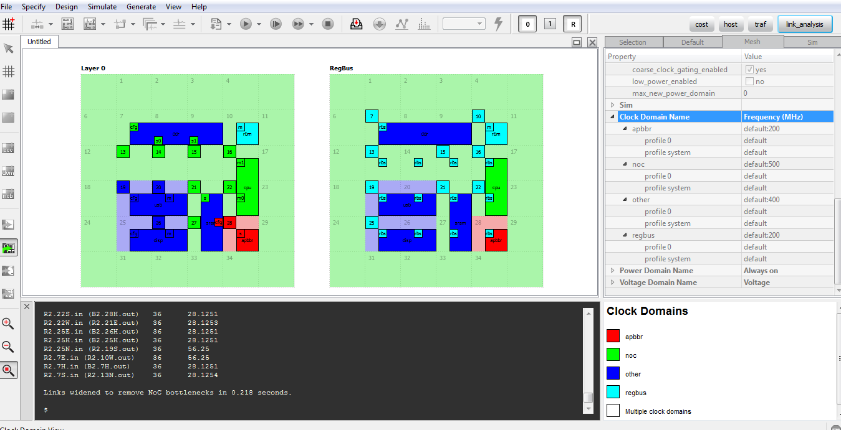

Figure 9. Multiple Clock Domains and Clock Crossings

The Regbus clock domain is fixed and asynchronous with the primary-layer clock domains. Therefore, all Regbus elements on the right panel are shown in the Regbus clock domain.

On the left panel displaying the primary layer, the routers in the *other* and *apbbr* clock domains use same clock. NocStudio assigns the specified clock domain to those routers and computes the link bandwidths and utilization with the specified domain frequency. The NocStudio performance simulator also uses domain frequency to dynamically model the transport and queuing in different NoC clock domains.

Bridge and host clock boundaries must be specified by the user and can be synchronous or asynchronous. NoC fabric clock boundaries are determined by NocStudio using the constraints in the clock-domain area specification supplied by the user. When crossing a clock-domain boundary between routers #20 and #21 in below figure, an asynchronous boundary is inserted at the router inputs.

Clock crossing between hosts and the NoC happen within a bridge. A list of clock crossing exists is generated by NocStudio in the NoC Reference Manual. There are different kinds of clock crossings. The “async” clock crossing refers to an asynchronous clock, where the frequency and phase of the clocks have no necessary relationship.

The “ratio_slow” and “ratio_fast” are phase-aligned synchronous clock crossers with an N:1 or 1:N ratio. “ratio_slow” refers to a clock crosser where the host is running slower than the NoC. The “ratio_fast” refers to a clock crosser where the host is running faster than the NoC. The synchronous clocks crossers require a frequency as well as a phase relationship. To achieve phase alignment, it is expected that the source of the ratio clocks will be the same. This structure works regardless of whether the source clock is faster, slower, or equal to the destination clock. The only requirement is that transfers happen only on a known shared rising edge. An external enable signal must be provided that indicates the cycle before the shared rising edge. This signal will be used to allow a transfer from the source clock domain to the destination clock domain.

Regbus clocks the ring at the primary-layer frequency used at the node, and the clock boundary between the ring and the Regbus frequency is implemented at the RingMaster. All primary layer NoC elements at a node use the same clock frequency, although they might have a clock boundary at their interfaces.

### In-Link Domain crossing (ILDC)

Any router-router or router-bridge link of the NoC can be configured to enable asynchronous clock domain crossing. This is an alternative to performing asynchronous clock domain crossing within router or bridge input VC buffers. ILDC partitions the NoC link into two independent domains with separate design hierarchies. Position of this structure on the link can be specified through NocStudio. The figure below shows that the structure is virtual channel aware and comprises of WR and RD partitions, which can be included into different module groups according to domains.



Figure 10 In-Link Domain crossing structure

#### Automated domain crossers

In earlier releases of NocStudio, routers containing one or more async ports were not skipped during mapping. It is now possible to skip the routers which have async ports, and instead have Domain Crossers be present across the async link. This is done through the *prop_default keep_routers_for_async*, which is set to “yes” by default, meaning that async routers are not skipped. When this prop is turned “no”, the async routers are skipped and instead, there are Domain Crossers added on the async links, under appropriate conditions.

For an asynchronous link, the Domain Crossers are added automatically in four cases:

1. When the keep_routers_for_async is set to “no” and the length of the link is more than 1000 um.
2. If the port is present on a router of an ecc or parity enabled layer
3. If the link is across two different RTL groups
4. If the link crosses voltage domains.

### Clock Gating

NocStudio and the generated RTL supports clock gating of NoC elements such as bridges, routers, and pipeline flops. There are two types of clock gating supported:

1. **Coarse-grained clock gating:** This is done at the NoC-element level based on its activity.
2. **Fine-grained clock gating:** This is done at the flop level within a NoC element.

Each NoC element has a clock input pin that connects to the element’s clock-distribution root. The synthesis tool does fine-grain clock gating by exploiting logic-level opportunities to insert local clock gating at the flop level. Coarse-grain clock gating is enabled using the NocStudio property:

mesh_prop coarse_clock_gating_enabled yes

By default, this property is set to no.

Below figure shows CFG NoC clock gating.



Figure 11. Clock Gating as Implemented in CFG NoC

#### Coarse-Grained Clock Gating

Applying coarse-grained clock gating to NoC elements saves power when those elements are idle for a period of time. This differs from fine-grained clock gating (usually done during logic synthesis) which controls clock gating on a cycle-by-cycle basis. Coarse-grained clock gating shuts off entire clock tree branches within a NoC element, saving power in ungated flops and in the clock network itself. Coarse-grained clock gating can be applied to the following elements:

* Routers
* AXI Bridges
* Pipeline stages inserted by NocStudio
* Regbus routers

Coarse-grained clock gating shuts off NoC elements under the following conditions:

* There are no transactions buffered or being processed internally, and all credits have been returned from the neighboring blocks.
* There are no transactions buffered and none inbound to the NoC element from a neighboring block.
* The inactivity described above has persisted for the programmed number of cycles.

A clock-gated NoC element awakes from its clock-gated state when a flit bound for the element is detected at a neighboring element. Because NoC elements can have registered or unregistered outputs, their internal pipelines differ and therefore have a different wake latency. An extra latency cycle can be incurred each time a NoC element wakes.

NoC bridges have a common counter that generates heart beat pulses at a programmable interval. These pulses are synchronized to different clock gating domains in the bridge. Within a bridge CG domain, four consecutive heatbeat pulses is used as the interval over which inactivity will initiate coarse clock gating of the domain. Similarly, NoC routers have a hysteresis counter value that determines the number of inactive cycles needed for a router to clock-gate itself. These intervals should be set high enough such that a few cycles of expected inactivity do not send the element into a clock-gated state, increasing the average path latency by forcing most packets to wake the element. Default value of hysteresis/hear-beat counters is 100 cycles; this default value can be configured through NocStudio properties. Further, the count values are programmable registers in the NoC elements and can be updated through regbus writes. Coarse-grained clock gating is managed by hardware, but in each NoC element, a programmable override register is provided to disable this feature.